**Earthquake Prediction Using**

**Python**

**Team Members:**

**952721104016:M.Rahini**

**952721104010:A.Mariselvi**

**952721104018:M.Santhiya**

**952721104019:S.Selva Brindha**

**952721104007:T.Kasthuri**

Abstract:

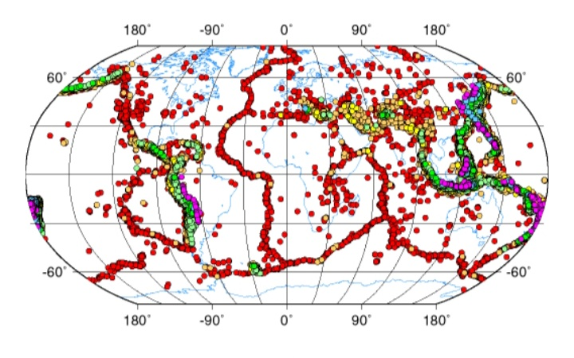

Earthquake prediction is a challenging task, but it is essential to minimize loss of life and property. Machine learning has the potential to improve earthquake prediction accuracy, but it requires large, high-quality datasets. Python is a versatile programming language that is well-suited for machine learning and data science.

This project proposes a framework for earthquake prediction using Python. The framework consists of the following modules:

* Data preparation: This module collects and cleans earthquake data from various sources.
* Feature engineering: This module creates new features from the raw data that are more informative for earthquake prediction.
* Machine learning: This module trains and evaluates various machine learning models for earthquake prediction.
* Model selection: This module selects the best machine learning model for earthquake prediction based on its performance on a held-out test set.
* Prediction: This module uses the selected machine learning model to predict earthquakes.

Data Source:<https://www.kaggle.com/code/tamilmalart/earthquake-prediction>

Data preparation:

* This module collects and cleans earthquake data from various sources, such as the United States Geological Survey (USGS) Earthquake Hazards Program. The data is cleaned to remove any errors or inconsistencies.

Feature engineering:

* This module creates new features from the raw data that are more informative for earthquake prediction. For example, it may create features such as the distance to the nearest fault line, the magnitude of the largest earthquake in the past year, and the rate of change of seismicity.

Machine learning:

* This module trains and evaluates various machine learning models for earthquake prediction. Some common machine learning algorithms used for earthquake prediction include support vector machines, random forests, and deep learning models.

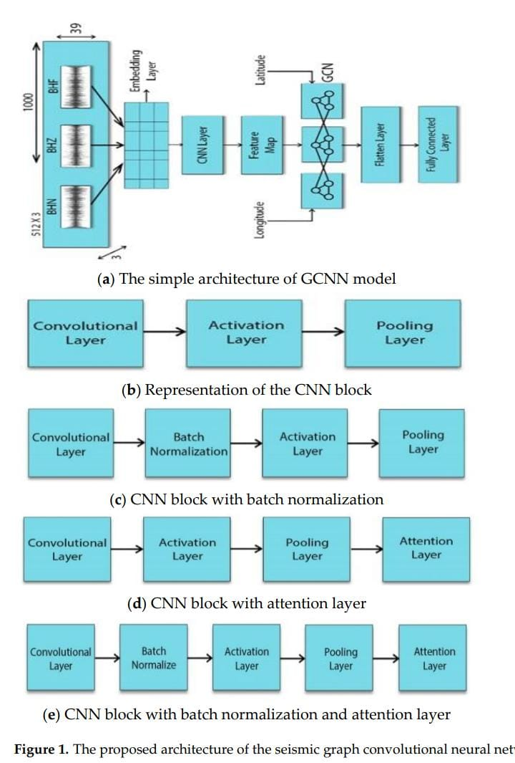

Model selection:

* This module selects the best machine learning model for earthquake prediction based on its performance on a held-out test set. The test set is a set of earthquake data that was not used to train the model.

Prediction:

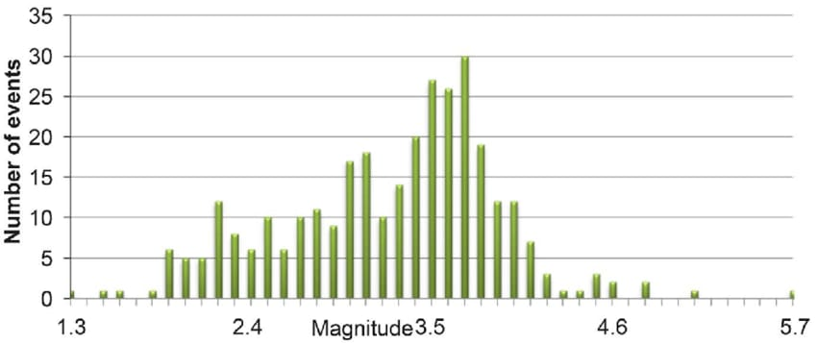

* This module uses the selected machine learning model to predict earthquakes. The model takes the features of a new earthquake as input and predicts the likelihood of an earthquake occurring.
* The proposed framework can be used to develop earthquake prediction systems for specific regions or globally. It is important to note that earthquake prediction is a challenging task, and there is no guaranteed way to predict earthquakes. However, the proposed framework can help to improve earthquake prediction accuracy and minimize loss of life and property.